WEEK 6
SESSION1: Maximum Subarray (Brute → Optimized)
TASK1:MAXIMUN SUBARRAY
PROGRAM:
class Solution {
public int maxSubArray(int[] nums) {
int currentSum = nums[0];
int maxSum = nums[0];
for (int i = 1; i < nums.length; i++) {
currentSum = Math.max(nums[i], currentSum + nums[i]);
maxSum = Math.max(maxSum, currentSum);
}
return maxSum;
}
}
OUTPUT:
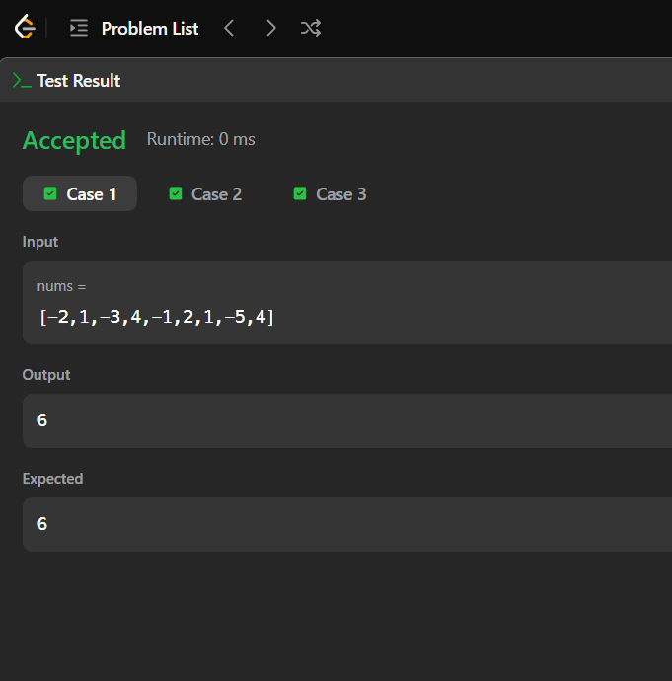
TASK2:THE BIRTHDAYBAR PROBLEM
PROGRAM:
import java.io.*;
import java.util.*;
class Result {
public static int birthday(List<Integer> s, int d, int m) {
int count = 0;
for (int i = 0; i <= s.size() - m; i++) {
int sum = 0;
for (int j = i; j < i + m; j++) {
sum += s.get(j);
}

if (sum == d) {
count++;
}
}

return count;
}
}
public class Solution {
public static void main(String[] args) throws Exception {
BufferedReader br = new BufferedReader(new InputStreamReader(System.in));
int n = Integer.parseInt(br.readLine().trim());
String[] arr = br.readLine().trim().split(" ");
List<Integer> s = new ArrayList<>();
for (String x : arr) {
s.add(Integer.parseInt(x));
}
String[] dm = br.readLine().trim().split(" ");
int d = Integer.parseInt(dm[0]);
int m = Integer.parseInt(dm[1]);
System.out.println(Result.birthday(s, d, m));
}
}
OUTPUT:
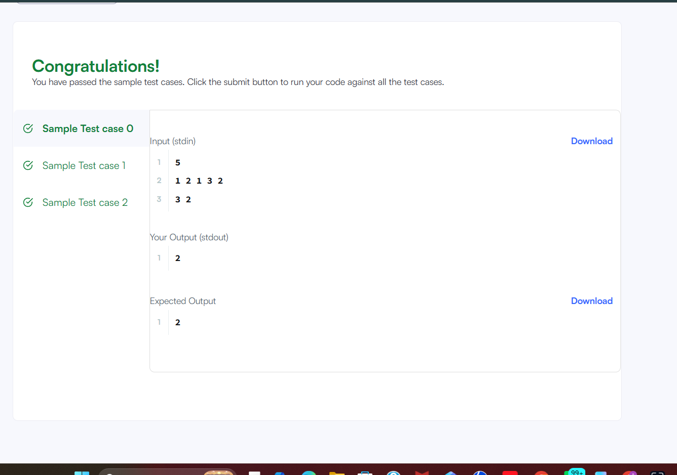

SESSION2: Kadane’s Algorithm
TASK3:MAX SUBARRAY
PROGRAM:
import java.io.*;
import java.util.*;
class Result {
public static List<Integer> maxSubarray(List<Integer> arr) {
int maxSubarray = arr.get(0);
int current = arr.get(0);
int maxSubsequence = arr.get(0);
for (int i = 1; i < arr.size(); i++) {
int value = arr.get(i);
current = Math.max(value, current + value);
maxSubarray = Math.max(maxSubarray, current);
if (value > 0) {
maxSubsequence += value;
} else {
maxSubsequence = Math.max(maxSubsequence, value);
}
}
return Arrays.asList(maxSubarray, maxSubsequence);
}
}
public class Solution {
public static void main(String[] args) throws Exception {
BufferedReader br =
new BufferedReader(new InputStreamReader(System.in));
int t = Integer.parseInt(br.readLine().trim());
while (t-- > 0) {
int n = Integer.parseInt(br.readLine().trim());
String[] input = br.readLine().trim().split(" ");
List<Integer> arr = new ArrayList<>();
for (String x : input) {
arr.add(Integer.parseInt(x));
}
List<Integer> result = Result.maxSubarray(arr);
System.out.println(result.get(0) + " " + result.get(1));
}
}
}
OUTPUT:
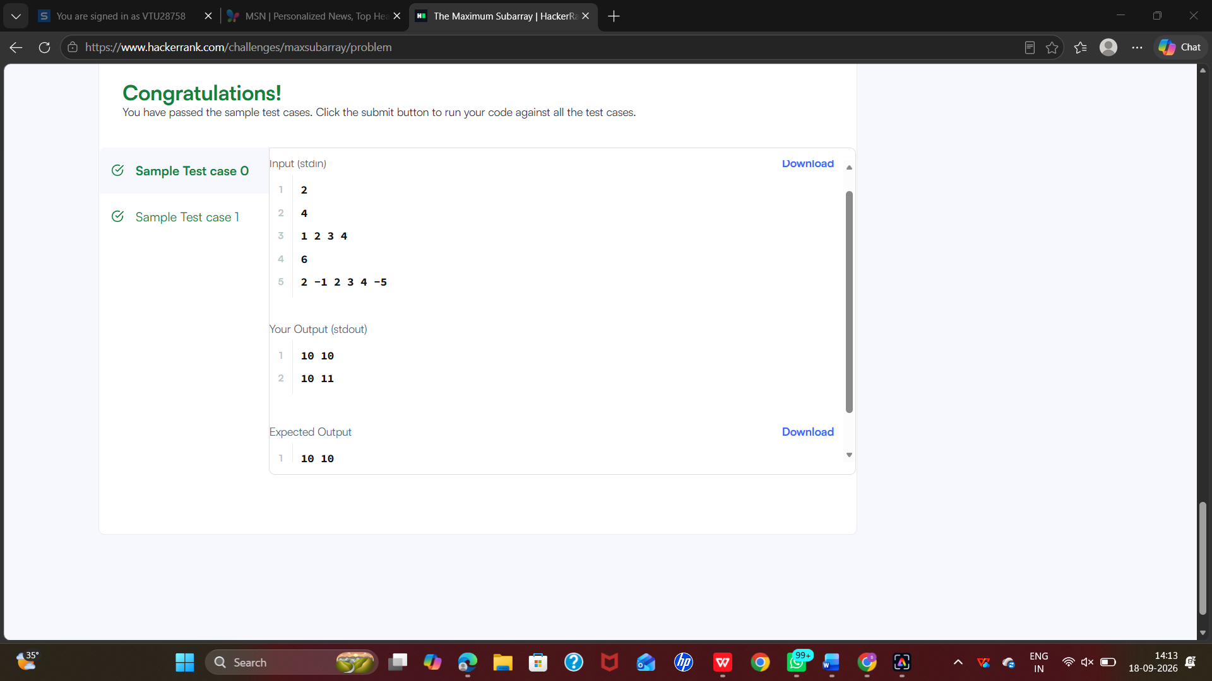

TASK4:MAX SUBARRAY SUM CIRCULAR
PROGRAM:
class Solution {
public int maxSubarraySumCircular(int[] nums) {
int total = 0;
int maxSum = nums[0];
int currentMax = 0;
int minSum = nums[0];
int currentMin = 0;
for (int num : nums) {
// Maximum subarray sum
currentMax = Math.max(num, currentMax + num);
maxSum = Math.max(maxSum, currentMax);
// Minimum subarray sum
currentMin = Math.min(num, currentMin + num);
minSum = Math.min(minSum, currentMin);
total += num;
}
// If all numbers are negative
if (maxSum < 0) {
return maxSum;
}
// Maximum circular sum
int circularSum = total - minSum;
return Math.max(maxSum, circularSum);
}
}

OUTPUT:
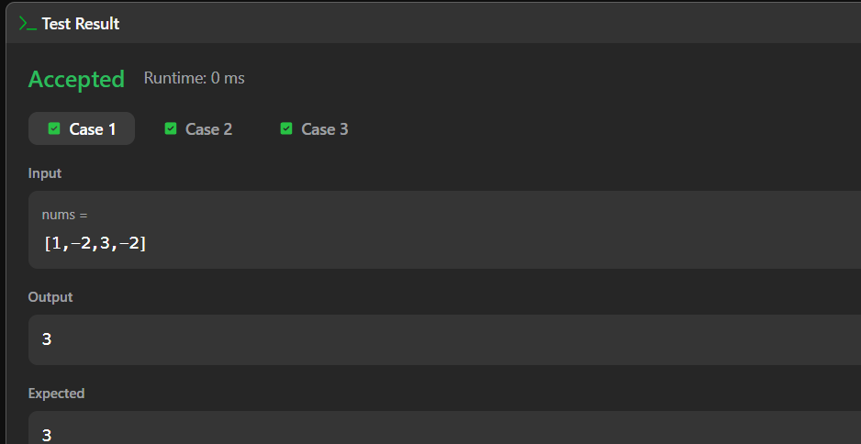

SESSION3: String Handling Basics
TASK5: string to integer atoi
PROGRAM:
class Solution {
public int myAtoi(String s) {
int i = 0, n = s.length();
long num = 0;
int sign = 1;
while (i < n && s.charAt(i) == ' ')
i++;
if (i < n && (s.charAt(i) == '+' || s.charAt(i) == '-')) {
if (s.charAt(i) == '-')
sign = -1;
i++;
}
while (i < n && Character.isDigit(s.charAt(i))) {
num = num * 10 + (s.charAt(i) - '0');
if (sign * num > Integer.MAX_VALUE)
return Integer.MAX_VALUE;
if (sign * num < Integer.MIN_VALUE)
return Integer.MIN_VALUE;
i++;
}
return (int) (sign * num);
}
}
OUTPUT:
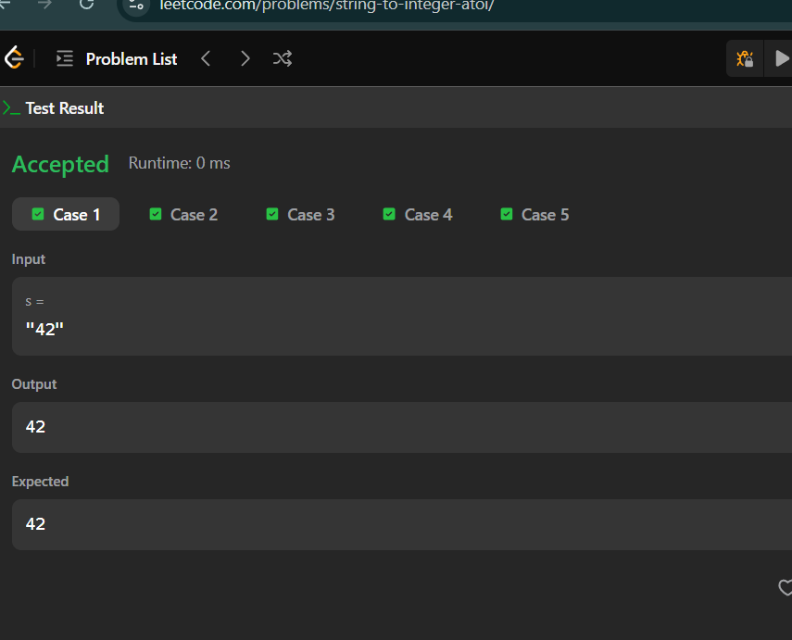
TASK6: alternating characters

PROGRAM:
import java.io.*;
import java.util.*;
class Result {
public static int alternatingCharacters(String s) {
int count = 0;
for (int i = 1; i < s.length(); i++) {
if (s.charAt(i) == s.charAt(i - 1)) {
count++;
}
}
return count;
}
}
public class Solution {
public static void main(String[] args) throws Exception {
BufferedReader br =
new BufferedReader(new InputStreamReader(System.in));
int q = Integer.pareInt(br.readLine().trim());
while (q-- > 0) {
String s = br.readLine().trim();
System.out.println(Result.alternatingCharacters(s));
}
}
}
OUTPUT:
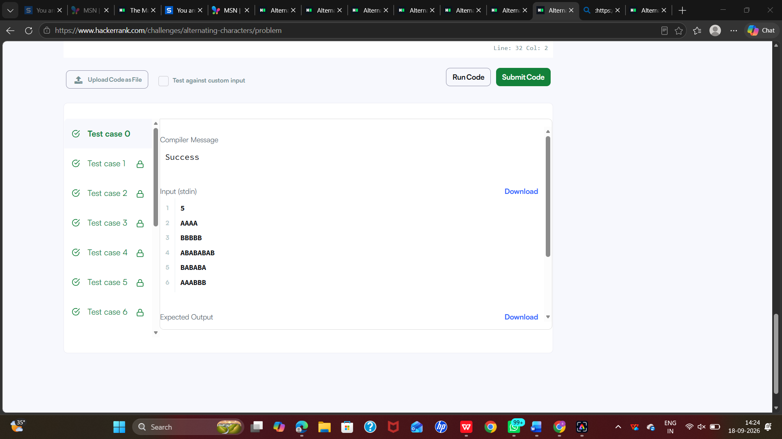

SESSION 4: Advanced String Techniques
TASK7: longest substring without repeating characters

PROGRAM:
class Solution {
public int lengthOfLongestSubstring(String s) {
int[] last = new int[128];
int left = 0, max = 0;
for (int right = 0; right < s.length(); right++) {
left = Math.max(left, last[s.charAt(right)]);
max = Math.max(max, right - left + 1);
last[s.charAt(right)] = right + 1;
}
return max;
}
}
OUTPUT:
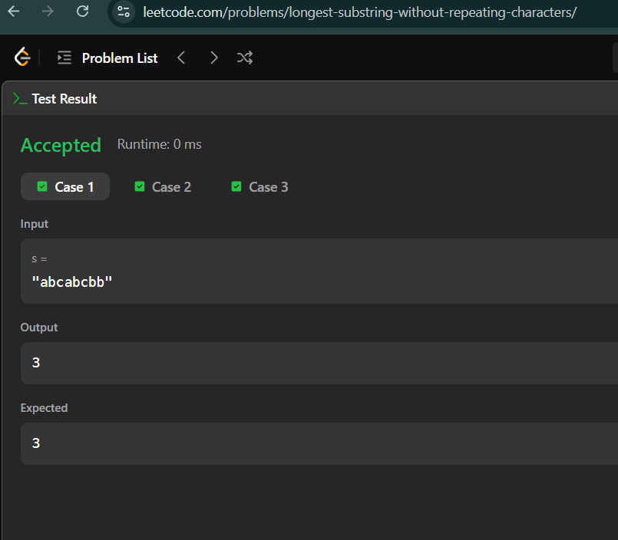
TASK8: find and replace pattern
PROGRAM:
class Solution {
public List<String> findAndReplacePattern(String[] words, String pattern) {
List<String> ans = new ArrayList<>();
for (String word : words) {
if (match(word, pattern))
ans.add(word);
}
return ans;
}
private boolean match(String word, String pattern) {
int[] a = new int[26];
int[] b = new int[26];
for (int i = 0; i < word.length(); i++) {
int x = word.charAt(i) - 'a';
int y = pattern.charAt(i) - 'a';
if (a[x] != b[y])
return false;
a[x] = i + 1;
b[y] = i + 1;
}
return true;
}
}
OUTPUT:
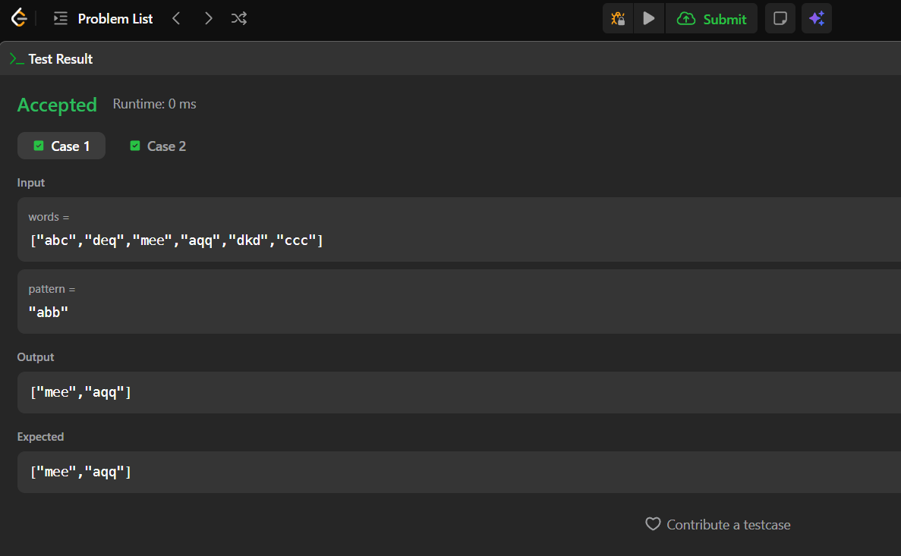
SESSION 5: Naive Pattern Matching
TASK9: string matching in an array
PROGRAM:
class Solution {
public List<String> stringMatching(String[] words) {
List<String> ans = new ArrayList<>();
for (int i = 0; i < words.length; i++) {
for (int j = 0; j < words.length; j++) {
if (i != j && words[j].contains(words[i])) {
ans.add(words[i]);
break;
}
}
}
return ans;
}
}
OUTPUT:
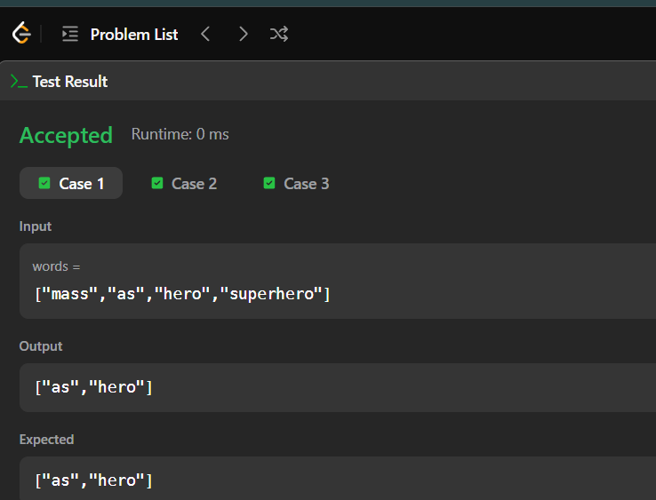

RESULT:Thus the week5 session has completed successfully.

